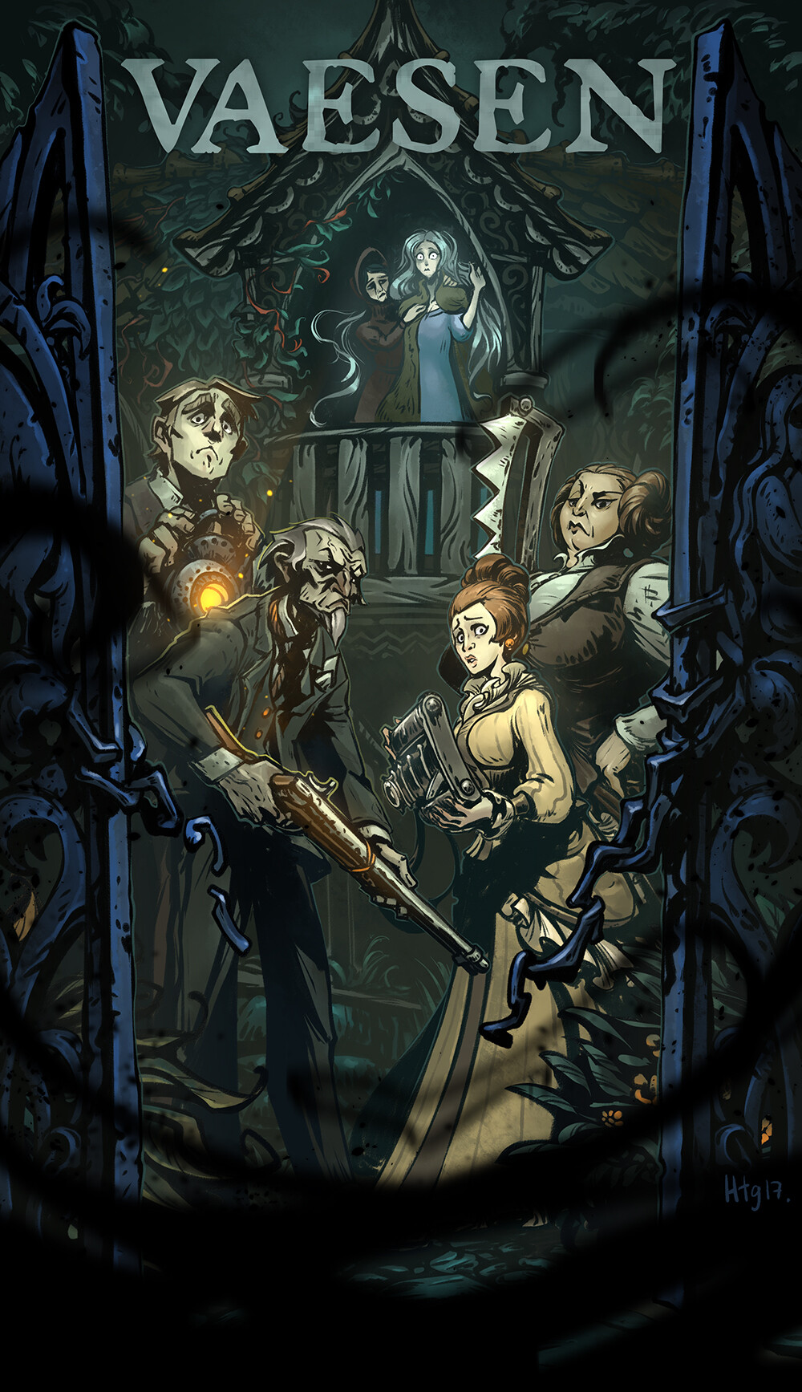

# Goal of this document

Most of the following topics are ***not*** fixed, rather they serve as a starting point for a *discussion*.

# “CATS”

## Concept

You play as investigators with *the Sight*, a supernatural ability to see mythical creatures, “Vaesen”, hidden to ordinary folk. Set loosely in the 19th century in an alternative, mythical Scandinavia.

The game will be episodic with no overarching plot. “Mystery of the week” vibe (think *CSI* and similar TV series). Characters and their headquarters will progress with time, but do not expect a D&D level of character customization.

## Aim

You are mystery and problem solvers, called upon when humans come into conflict with the supernatural Vaesen. Your investigations will be solved using wits, social skills, and weapons.

## Tone

Serious. We will decide if we want primarily: horror, adventure, or mystery. Characters are professionals, so a low roll will never mean “you trip on own sword and fall on your butt”. Jokes and laughs are *encouraged,* but do not laugh at the expense of the spooky stuff (so no “Haha Cthulhu big tentacle hentai monster”).

## Subject Matter

We will deal with adult topics (sex, torture, manipulation, discrimination based on nationality/gender/race/belief etc), but the degree depends *entirely* on your feedback to the checklist ***so answer them and send them to me privately!***

Other subjects include: Man vs nature, tradition vs modernity, religion vs materialism.

# Safety tool discussion

Follows up on the surveys you have answered.

**X-card**Each of us has the right to say: “I’d like to skip over this part of the story” without having to explain why. Some people find it useful to use a literal or metaphorical X-card to symbolize the skip. Would people like that?

# Gameplay Expectation from players

Bring your character sheet, either digitally or physically. Make sure you have access to the rules, again, either digitally or physically.

Most importantly, come with the mindset that no matter what, you will have an enjoyable time playing. This is *crucial* for everyone’s experience.

# Logistics

**Game scheduling**

*Ideally*: Fixed day and time every 2(?) weeks (e.g. every other Thursday from 16-21)

*Alternative*: Every month I post the dates that I can run the following months. The days with enough players are run. Also need to decide on what app we use for scheduling. Messenger, Discord, Doodle are options.

**Game duration**

*Weekdays*: 3 hours (Mysteries take several sessions)

*Weekend*: 4-5 hours (A mystery can be done in one session)

**Breaks**

Fixed or when we feel like it?

**Food & Snacks**

*Short games*: People bring their own food.

*Long games*: Either cook together, order or bring own food.

*Snacks*: Do we need a system, or do we just expect people to bring something? Opportunities for non-sugary snacks.

**Player is late or cancels**

Will be run if there are 2 or more players.

**Online play**

Can people join on a physical game from home?

# Comfort and Accessibility

**Language**

The primary language of the game is Danish, but if you are more comfortable with English, you are welcome to either only or partially speak that. Rules stuff will of course be done in English (I don’t want to translate Wizard, Witch, Sorcerer and Warlock to Danish).

**Positive atmosphere**

The following are less points of discussion, and more me reinforcing that you are allowed to be a person while at the gaming table 😊.

1. You are allowed to get up and stretch.
2. You are allowed to keep your hands occupied with knitting, drawing, painting, and assembling minis etc., as long as you can keep the mental focus on the game.
3. You can use phones/tablets for note keeping and similar, but make sure it is not distracting you or the other players.

# Session 0 Wrap-up

Did we miss something?

Remember, if you later find a safety tool or similar that you would like to bring to the game, please text me about it.